Exercise: Purpose-driven, Massive Action Plan
Step 1, Focus
You mentioned that you want to learn to control your Focus. Remember we get what we focus on. What you focus on determines how you’ll feel!
Trick to control your focus and thoughts is the 90 second rule. Use it when you feel unwanted emotions coming up.
Remember the example I have showed you about the NOW, Past and Future. When you live in the past and thinking about all the things that happened there and you feel the emotions. You are not in the now. And when you think about the future and you expect things already to happen you are living in the predictable future. This all cost you a lot of enery and you are not living in the present moment.
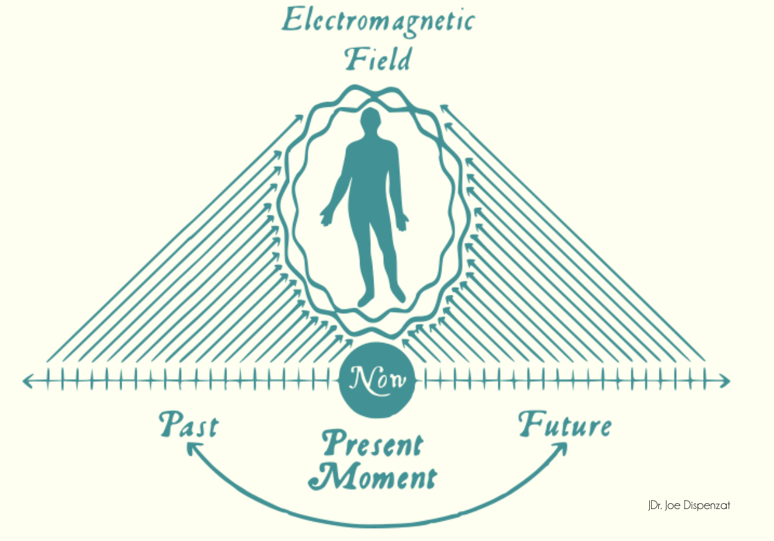
By changing your focus, you instantly transform the quality of your life. In fact, when you make a simple shift in focus, you can immediately go from being totally depressed to totally euphoric. And your focus also directly affects your results.
What we want to create is a system that causes you to consistently focus on what you WANT in life. So many things constantly compete for and demand your focus in life. If you don’t make a conscious effort to control your focus – and decide in advance exactly where you’re going put your emotions, time and energy – you’ll soon find yourself living in reaction to the world’s demands instead of living a life plan you’ve designed for yourself.
That is why I let you do the bucket list exercise. To see where you really want to put your focus on. You mentioned that this is building. And you would rewrite it this week.
- Build your own professional website and blog
- Build a vinyl website
- Build a product

Next step is ask yourself the right questions.
The quickest way to change your focus Is by asking questions. The questions you ask yourself control what you focus on. Remember, the process of thinking is nothing more than the process of asking and answering questions. You may not realize it, but you ask yourself questions all day long! The challenge most people face is that they are not conscious about the questions they ask themselves.
So you can start by asking yourself new, more empowering questions.
Sit down and think about the three buckets and answer these 3 questions. It is important to do this in this sequence.
- What do I really want? What is my outcome? What Result am I committed to achieving?
I want to finish off(well, restart) projects and ideas that have been running in my head for a very long time(some of them for more than 10 years..), but now with more maturity and wisdom.
The outcome is to balance my thoughts and give the sense of achieving, while learning, spending hours to build and enjoying the fruit of this labour, which is for myself to grow forward.
The result I commit to achieve is to have results!

- Why do I want to do this? Why is it a “must” for me to get this Result? What will it give me? What’s my Purpose?
Exactly, my purpose is to have a purpose that is able to fulfill me and get me unstuck from the past, put me on the steering wheel of my life and take control of those things that I know I can achieve.
I need to do this, I must do this, I have known I need to do this for a very long time and I know I have the skills, knowledge and mindset to do so! SO WHY THE HELL NOT DO SOMETHING FINALLY????????????????????????????????????????????

- What are the specific actions I need to take in order to achieve this result? How can I best achieve it now? What is my Massive Action Plan?
FOCUS
THINK

ACT – TODAY!

